Quiz#8
Section: __________________________ Group: _______________________
Name(print): ______________________________ Student ID: _________________________
- A 4.5 kg cart initially moving at 2.1 m/s collides with a wall and rebounds at a speed of 1.3 m/s moving backward. The collision lasts for 0.2 seconds. What is the average force exerted on the cart during the collision?
- 47.3 N.
- 18 N.
- 76.5 N.
- None of the above is correct.

- A blue car with mass m_{c} is moving east with a speed of v_{c} and collides with a purple truck with mass m_{t} that is moving south with a speed of v_{t} . The two collide and lock together after the collision. Let us define to the east is the +x direction and to the north is the +y direction. Which of the following statements is correct?
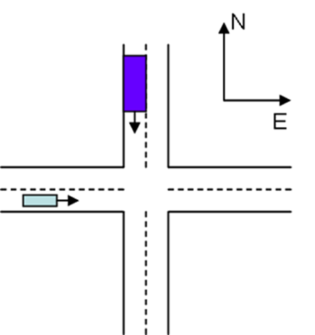
- The total momentum of the car-truck system remains to be a constant before and after the collision.
- The total kinetic energy of the car-truck system remains to be a constant before and after the collision.
- The y-component of the total momentum of the car-truck system before the collision is greater than the y-component after the collision.
- The x-component of the total momentum of the car-truck system before the collision is greater than the x-component after the collision.

- A 78kg hockey goalie is originally at rest protecting his goal. The opposing team attempts a shot on goal, however the goalie catches the 170g puck with his glove. The initial velocity of the puck before the goalie catches it is 150 km/hr. What is the speed of the goalie after catching the puck?
- 0.077 m/s
- 0.091 m/s
- 102 m/s
- 28.6 m/s

